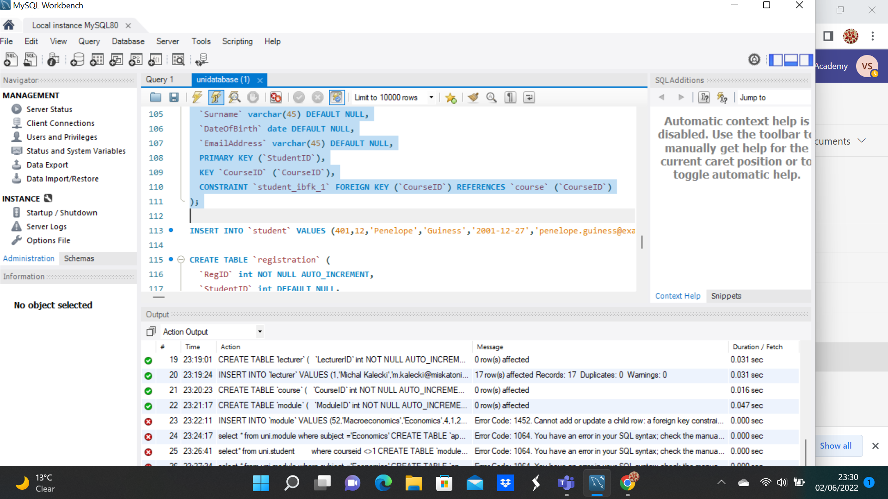

- Count how students are enrolled overall

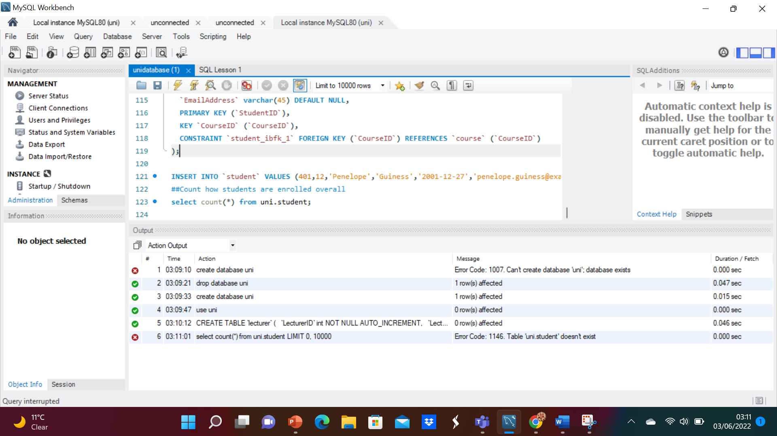
- Calculate the sum of full time fees for every full-time course
- Identify the cost of the least and most expensive course

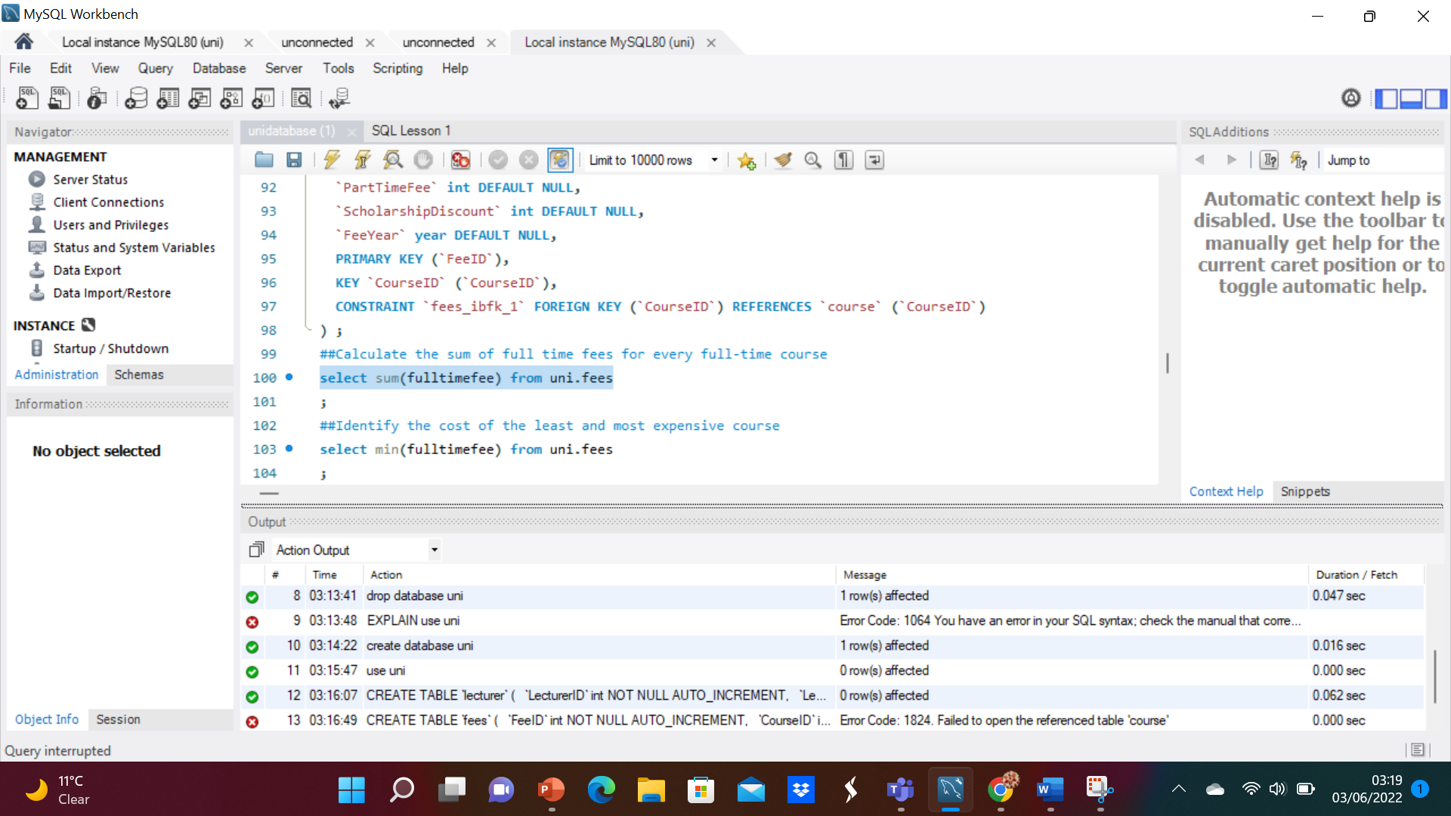

Calculate the average cost of all part time courses
Calculate the fee of each full time course after applying (subtracting) the scholarship discount
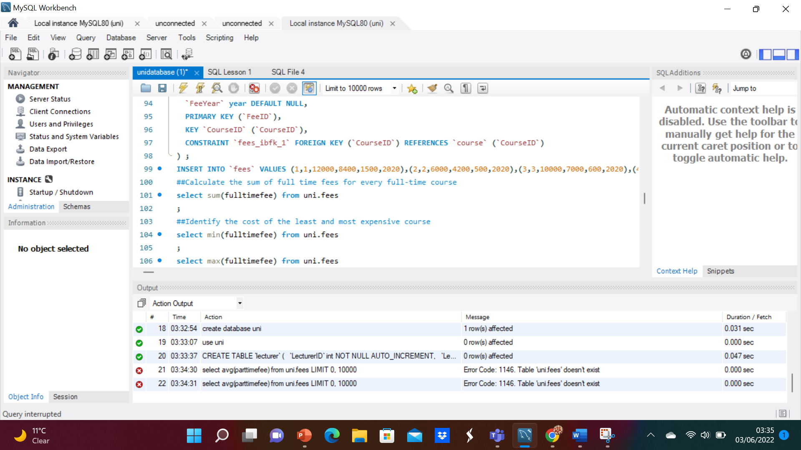

- Extension:
- Select only the course number of the cheapest full-time course
- Find cost of the most expensive course after applying the scholarship discount
- 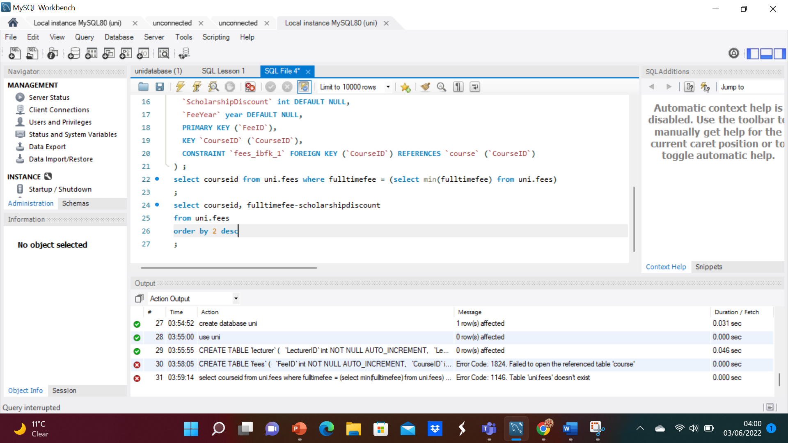

- Count the number of applications for History courses made between 01/03/2020 and 30/08/2020
